**SWARM ROBOTICS**

Ebin Thoppil George - St. Josephs College Of Engineering And Technology, Palai

Roshan Thomas - St. Josephs College Of Engineering And Technology, Palai

**INTRODUCTION**

**Swarm** describes a behavior of an aggregate of animals of similar size and body orientation, generally moving *en mass* in the same direction. The term can be applied to fish, insects, birds, various microorganisms such as bacteria, and people.

Eg: Ants and bees.

### Software from Insects

### The main goal of my research is to understand how to use local interactions between nearby robots to produce large-scale group behaviors from the entire swarm. This idea is not new; in fact it is almost 65 million years old. Ants, bees, and termites are beautifully engineered examples of this kind of software in use. These insects do not use centralized communication; there is no strict hierarchy, and no one in charge.

However, developing swarm software from the "top down", i.e. by starting with the group application and trying to determine the individual behaviors that it arises from, is very difficult. Instead, I am developing a library of "group behavior building blocks" that can be combined to form larger, more complex applications. The robots use these behaviors to communicate, cooperate, and move relative to each other. Some behaviors are simple, like following, dispersing, and counting. Some are more complex, like dynamic task assignment, temporal synchronization, and gradient tree navigation. There are currently about forty of these behaviors. They are designed to produce predictable outcomes when used individually, or when combined with other library behaviors, allowing group applications to be constructed much more easily.

**Ant colony**

Ants form colonies that range in size from a few dozen predatory individuals living in small natural cavities to highly organized colonies which may occupy large territories and consist of millions of individuals. These larger colonies consist of females called "queens", who rules the entire colony. The ants operate as a unified entity, collectively working together to support the colony. Ant societies have division of labour, communication between individuals, and an ability to solve complex problems.

**SWARM INTELLIGENCE**

**Swarm intelligence (SI)** is a type of artificial intelligence based on the collective behavior of decentralized, self-organized systems.

SI systems are typically made up of a population of simple agents or boids interacting locally with one another and with their environment. The agents follow very simple rules, and although there is no centralized control structure dictating how individual agents should behave, local, and to a certain degree random, interactions between such agents lead to the emergence of "intelligent" global behavior, unknown to the individual agents. Natural examples of SI include ant colonies, bird flocking, animal herding, bacterial growth, and fish schooling.

The application of swarm principles to robots is called swarm robotics, while 'swarm intelligence' refers to the more general set of algorithms. 'Swarm prediction' has been used in the context of forecasting problems.

**SWARM ROBOTICS**

Swarm robotics is a new approach to the coordination of [multi-robot systems](http://en.wikipedia.org/w/index.php?title=Multirobot_system&action=edit&redlink=1) which consist of large numbers of mostly simple physical [robots](http://en.wikipedia.org/wiki/Robot). It is supposed that a desired [collective behavior](http://en.wikipedia.org/wiki/Collective_behavior) emerges from the interactions between the robots and interactions of robots with [the environment](http://en.wikipedia.org/wiki/Environment_%28biophysical%29). This approach emerged on the field of artificial swarm intelligence, as well as the biological studies of insects, ants and other fields in nature, where [swarm](http://en.wikipedia.org/wiki/Swarm) behavior occurs.

Swarm robotics assumes that a given mission is the result of a joint action of a swarm of simple units. Such units in theory might even be unable to perform the bare locomotion without the aid of others of their kind.

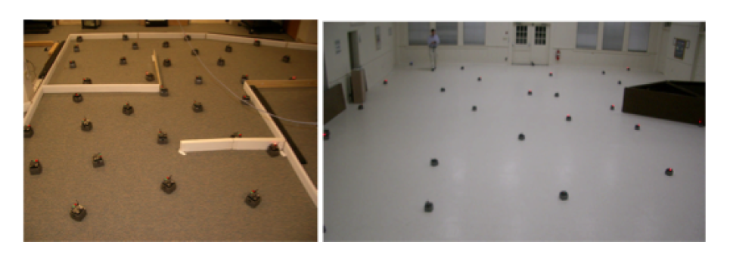

**From centralized intelligence to swarm intelligence**

The basics of programming code of the future i.e. diffuse applications codes, are based on three main principles:

First, the interaction between the codes of two objects becomes weaker as the number of objects increases. Non-synchronized communication is therefore the future of programs based on swarm intelligence that run parallel to one another.

Secondly, the notion of micro-components is strongly connected to the spreading of the code that is controlled on a macroscopic level.

Last, but not least, algorithms need to adapt to certain problems, i.e. they need to find methods to solve problems themselves. Future programs will develop according to the task they carry out within their environment. The concept uses mutant applications.

**Scope**

The focus of Swarm Robotics is to study how a swarm of relatively simple physically embodied robots can be controlled to collectively accomplish tasks that are beyond the capabilities of a single robot. The advantages of swarm robotics are that (1) complex control is achievable through simple local interactions of the swarm members, (2) the results scale well with larger numbers of robots, and (3) the swarm is robust to failure of individual members. Algorithms, techniques and methods based on swarm robotics principles have been successfully applied to a wide range of complex problems. This special issue aims at exhibiting the latest research achievement, findings and ideas in the area of Swarm Robotics.

**DEFINITION**

The research of swarm robotics is to study the design of robots, their physical body and their controlling [behaviors](http://en.wikipedia.org/wiki/Behavior). It is inspired but not limited by the [emergent behavior](http://en.wikipedia.org/wiki/Emergent_behavior) observed in [social insects](http://en.wikipedia.org/wiki/Social_insect), called [swarm intelligence](http://en.wikipedia.org/wiki/Swarm_intelligence). Relatively simple individual rules can produce a large set of complex swarm behavior. A key-component is the communication between the members of the group that build a system of constant feedback. The swarm behavior involves constant change of individuals in cooperation with others, as well as the behavior of the whole group.

Unlike [distributed robotic systems](http://en.wikipedia.org/w/index.php?title=Distributed_robotic_system&action=edit&redlink=1) in general, swarm robotics emphasizes a large number of robots, and promotes [scalability](http://en.wikipedia.org/wiki/Scalability), for instance by using only local communication. That local communication for example can be achieved by [wireless](http://en.wikipedia.org/wiki/Wireless) transmission systems, like [radio frequency](http://en.wikipedia.org/wiki/Radio_frequency) or [infrared](http://en.wikipedia.org/wiki/Infrared).

[Video tracking](http://en.wikipedia.org/wiki/Video_tracking) is an essential tool for systematically studying swarm-behavior, even though other tracking methods are available. Recently [Bristol robotics laboratory](http://en.wikipedia.org/w/index.php?title=Bristol_robotics_laboratory&action=edit&redlink=1) developed an ultrasonic position tracking system for swarm research purposes. Further research is needed to find methodologies that allow the design and reliable prediction of swarm behavior when only the features of the individual swarm members are given.

[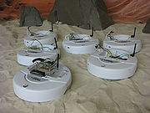](http://en.wikipedia.org/wiki/File:IRobot_Create_team.jpg)

**Swarm communication**

In swam robotics, communication scheme is the topic which is mostly considerably studied recent years. Basically, to deploy a swarm of mobile robots, each robot should be able to communicate with its neighbours through means of communications including, explicit, implicit, state, or situated communications, instead of using global communication.

Relying on the communication method, a robot can transfer commands, detect the relative positions of other robots; control the swarm w.r.t specific tasks, etc. In the communication mode, three key factors of signals should be taken into account: mean of communication, communication directivity, and relative distance. Three key parameters are necessary and sufficient to setup any topology of dynamic network of mobile robots.

**Learning**

The smart infrared and ambient light sensor boards have already been developed and tested for use. Therefore, the main mission of the project group will be

- Understanding about principles of swarm communication using diversity of sensor and communication technologies

- comprehending fundamental knowledge of swarm robotics and related fields

- Local communication in swarm robotics

- Flexibility, adaptability, scalability in swarm robotics

- Robot coordination w.r.t communication protocol



**GOALS AND APPLICATIONS**

Both miniaturization and cost are key-factors in swarm robotics. These are the constraints in building large groups of robotics; therefore the simplicity of the individual team member should be emphasized. This should motivate a swarm-intelligent approach to achieve meaningful behavior at swarm-level, instead of the individual level.

Potential applications for swarm robotics include tasks that demand for [miniaturization](http://en.wikipedia.org/wiki/Miniaturization) ([nanorobotics](http://en.wikipedia.org/wiki/Nanorobotics), [microbotics](http://en.wikipedia.org/wiki/Microbotics)), like distributed sensing tasks in [micro machinery](http://en.wikipedia.org/wiki/Micromachinery) or the [human body](http://en.wikipedia.org/wiki/Human_body). On the other hand swarm robotics can be suited to tasks that demand cheap designs, for instance [mining](http://en.wikipedia.org/wiki/Mining) tasks or agricultural [foraging](http://en.wikipedia.org/wiki/Foraging) tasks, handling of dangerous materials. Also some artists use swarm robotic techniques to realize new forms of [interactive art](http://en.wikipedia.org/wiki/Interactive_art). Given such a multi-purpose nature, swarm-bots might also find further applications in the future which are currently even not foreseen.

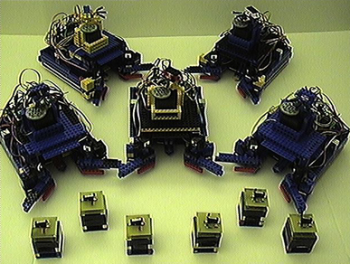

**REAL TIME APPLICATIONS**

1. The Autonomous Inspection of Complex Engineered Structures.

### Ability to work in extreme conditions.

### A swarm-bot as a service robot.

### The U.S. military is investigating swarm techniques for controlling unmanned vehicles.

### NASA is investigating the use of swarm technology for planetary mapping. The day won’t be far when swarms of robots will be exploring space or doing dangerous jobs on Earth, as it is now possible to create self-assembling robot chains as well as tiny robots for just 24 pounds, say researchers. Some complex robot that is sent to Mars has a technical problem, and then the mission is basically over. With swarm robots, even if a percentage of them fails, they’ll still be able to achieve their goal,

### Swarm intelligence to control nano-bots within the body for the purpose of killing cancer tumors.

### Hospital Robot Swarm: Situation Recognition Module - The aim of this module is to recognise a patient lying on the floor using a camera and a laser sensor. Image recognition techniques will be applied to the images.

1. Hospital Robot Swarm: Intruder Monitoring Module - The aim of this module is to recognise an intruder in the hospital using a PIR sensor, camera and laser sensor. Image recognition algorithms will be used.
2. Hospital Robot Swarm: Spot Cleaning Module - The aim of this module is to develop a module that can clean up spillages in a ward. The spillage area will be marked by a cone with infrared LEDs. The cleaning device will be developed in another project, in this project an infrared vision system will be created that will guide the robot to the cone using an infrared camera.

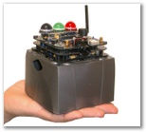 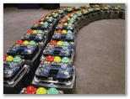

**PROSPECTS**

1. I-SWARM PROJECT: **Intelligent Small World Autonomous Robots for Micro-manipulation (I-Swarm),** is a European research project to develop millimeter-scale robots for dangerous activities. The I-Swarm project aims to develop and produce a large scale swarm (up to 1,000) of micro robots. Swarm robots are expected to have a variety of applications, including micro assembly, biological, medical or cleaning tasks. The robots' proposed size is 2 x 2 x 1 mm. This small size means that sensory and computational capabilities will be limited.
2. SYMBRION: **Symbiotic Evolutionary Robot Organisms** is a project funded by European Commissions to develop a framework in which a homogeneous swarm of miniature interdependent robots can co-assemble into a larger robotic organism to gain problem-solving momentum. One of the key-aspects of Symbrion is inspired by the biological world: an artificial genome that allows to store and evolve (sub) optimal configurations in order to achieve an increased speed of adaptation. The symbrion project does not start from zero, previous development and research from project I-SWARM and the open-source SWARMROBOT projects serve as a mounting point. A large part of the developments within Symbrion is open-source and open-hardware.

### The Future

Robots are going to be an important part of the future. Once robots are useful, groups of robots are the next step, and will have tremendous potential to benefit mankind. Software designed to run on large groups of robots is the key needed to unlock this potential.

**REFERENCES**

* Swarm-Robotics.org - http://www.swarm-robotics.org/.
* The Swarm-bots project - http://www.swarm-bots.org/
* I-SWARM - http://www.i-swarm.org/ - The European I-SWARM project. Goal is to build a massive swarm of up to 1000 3mm x 3mm x 3mm sized autonomous robots.
* Bristol robotics laboratory - Research lab for both behavior based robotics and swarm robotics.
* SYMBRION - <http://www.symbrion.eu/> - Symbiotic Evolutionary Robot Organisms
* http://www.idi.ntnu.no/grupper/ai/eval/fdagene/ - Collective emergent robotics/swarm robotics example, with an on-line video of an experiment with four robots
* http://en.wikipedia.org/wiki/Swarm_robotics